**Assignment** EFS -02: QUANTITATIVE STRATEGY MODELING IN EXCEL

**Note:** If there are multiple files for the assignment, please zip all the files in .zip format.

**Submitted By:**

|  |
| --- |
| **Question:** Make sure that you complete the model discussed in the class and work on the data as provided in the “In_Class_EFS-02_File” which was used in class. Check the sheet “Desired Output”. You have to calculate following values using various excel formulas discussed in the class:  Answer:  Please find below outcomes for model. |

|  |  |
| --- | --- |
| **Parameters** | **Values** |
| Number of Long Signals | 225 |
| Number of Short Signals | 181 |
| Total number of Signals | 406 |
|  |  |
| Number of Long Signals Traded | 44 |
| Number of Short Signals Traded | 45 |
| Total number of Signals Traded | 89 |
|  |  |
| Number of Profitable Trades | 8 |
| Number of Loss Making Trades | 81 |
| Profit from Profitable Trades | 180.8961 |
| Loss from loss making trades | -903.075 |
| Total Profit or Loss | -722.179 |
|  |  |
| Average Number of Signals per Trading Hour | 34.84979 |
| Average Number of Trades per Trading Hour | 7.639485 |
| Average Holding Period of a Trade (in minutes) | 7.617978 |
|  |  |
| Maximum Profit from a trade | 23.62029 |
| Maximum Loss from a trade | -12.374 |
| Average Profit (or Loss) Per Trade | -8.11437 |
| Assumed Slippage (assume a value) | 0.2 |
| Brokerage (assume a value) | 0.3 |
| Net Profit or Loss per trade after costs | -9.11437 |
| Total Net Profit or Loss after costs | -811.179 |

🡪Please below note points which are used while calculating above table.



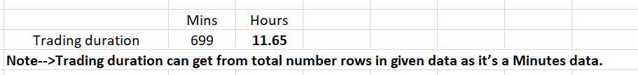



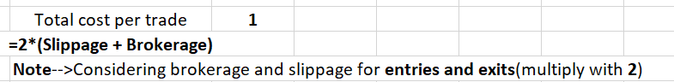

* Make sure that you are not doing these calculations manually. All computations need to be done using excel formulas.
* Upload your final model along with completed table of values.
* **Note:** If there is more than one file kindly zip it in .zip format.